OYO ROOMS

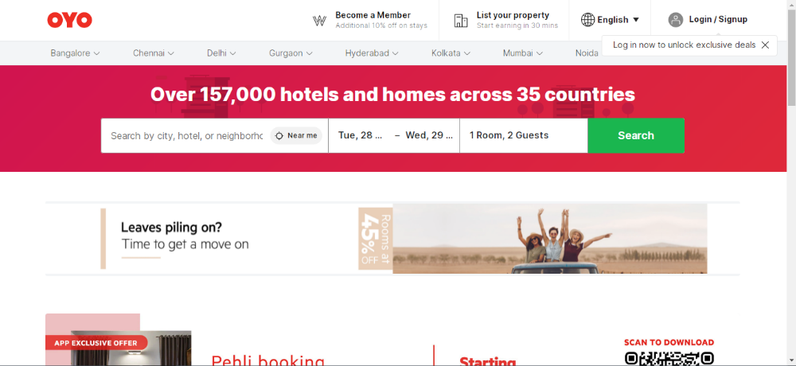

AIM:
To create the hotel booking website OYO ROOMS using MERN technology.

HOME PAGE:
Navbar - logo, language option, signup/login
List of the various cities and popular locality
Searching Section – Search hotel, date , no of person,
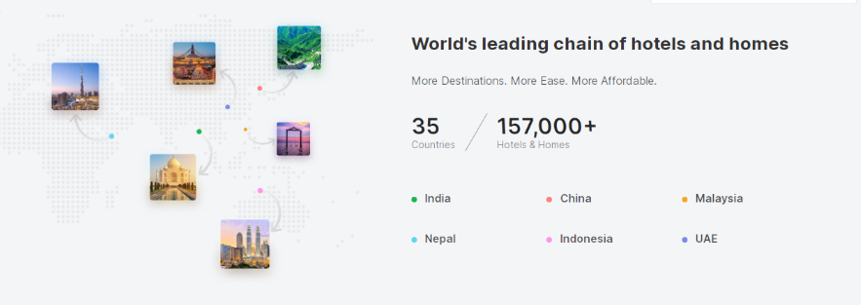
Adverstisement Section
Footer – Hotels in various cities

Listing Page:
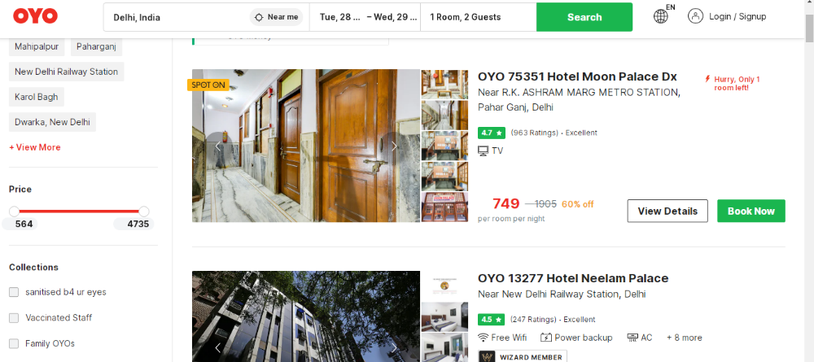
Filter – Search location, pricing, Different premium categories
Card – Hotel pic, Hotel details, Price, view details

Details Page:
Hotel pictures and details, Hotel location, Hotel reviews, and payment option
